Changelog for Group 10

Adam Luong

Benny Mai

Dakota Wessel

Jacky Zheng

Tony Zhu

November 28, 2020  
Release 6.0

Change Log

# **11/17/2020 - Release 1.0:**

* Main Menu
* Game Screen
  + Offline Checkers Functionality:
    - Can Take Pieces
    - Move Pieces
    - One King available at start for both sides
* Instructions

# **11/19/2020 - Release 2.0:**

* Timer
* Game Screen (Still Offline)
  + Must Take Pieces if available
  + Pieces will be highlighted in orange when a possible jump needs to be made
  + Player’s turns will display in the top center
  + Player’s cannot move during the opponents turn
  + Pieces will automatically be taken if jumping more than once

# **11/20/2020 - Release 3.0:**

* Game Screen (Still Offline)
  + Winners will be declared when no pieces remain for one player
  + When jumping more than once the jumping player must click for each individual jump
  + When regular pieces reach the opposite end of the board, they will be King’d

# **11/22/2020 - Release 4.0:**

* Game Screen:
* Online Functionality added
* Rooms can only be joined from Game Screen
* Create Game does not create GameCode

# **11/25/2020 - Release 5.0:**

* Game Screen:
  + Users can now only move on their own turns
  + Game Code is automatically generated
  + Only 2 Users can be in one game session
  + Player colors are indicated on the top of the screen
  + Timer added:
    - If timer reaches 0, Game will end, and another player will be declared as winner
    - Timer is set to 5 minutes
    - Timer resets after every move
* Join Game Screen
  + Can now join game from this screen using game code

# **11/28/2020 - Release 6.0:**

* Rematch Screen  
   Screen appears and declares winner
  + Can call rematch
* Game Screen
  + Other player can no longer call jumps for opponent

Current Bugs (Via Github):  
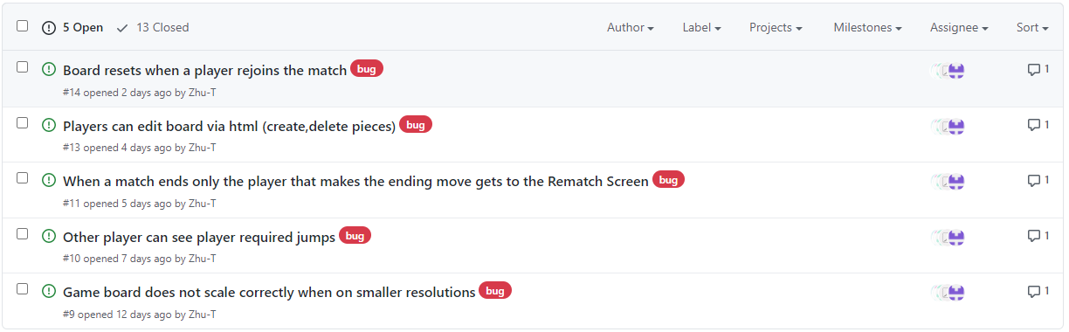

**We only used comments to mark severity, so I’ll mark these here:**

* Board resets when a player rejoins the match (Severity – Low)
  + Only occurs in cases of reconnects
* Players can edit board via html (Severity – Low)
  + Many users probably will not see this bug or figure out that it exists
* When a match ends only the player that makes the ending move gets to the Rematch Screen (Severity – Medium)
  + This makes the rematch functionality useless until fixed
* Other player can see player required jumps (Severity – Low)
  + Visual bug does not affect gameplay
* Game board does not scale correctly when on smaller resolutions (Severity – Low)
  + Intended support was for desktops and so scaling will most likely not be a issue unless they resize the browser

Fixed Bugs(Via Github):

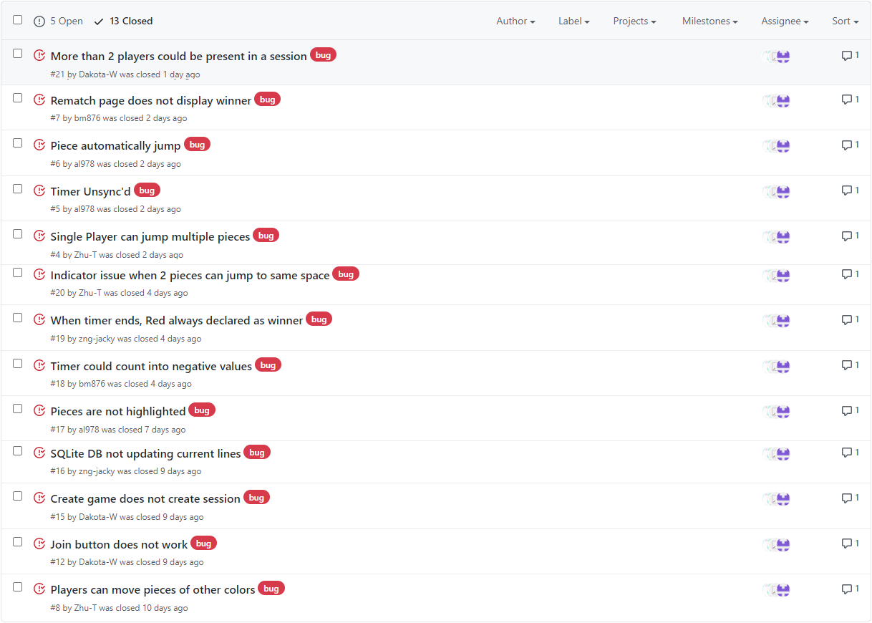

Included Functionality:

* Chrome tested support assessable through URL when server is up
* Gameboard:
  + Possible moves are shown for the player’s piece when clicked
  + Displayers player’s color and which player’s turn it is
  + displays 5-minute timer that causes a loss if time runs out
    - Timer resets after each move
  + Players can take pieces, and take multiple pieces when allowed
  + Players can move pieces
* Main Menu:
  + All 3 buttons navigate to the desired pages
    - **Create Game** **button** creates new game with unique code
    - **Join game button** navigates to join game page
    - **Instructions button** page navigates to instructions page
* Join Game:
  + Players can input code to join a game session
  + Players cannot join a session with 2 players already connected
* Rematch:
  + Page displays after game ends (current bug where it only displays for both users in the case of a time out)
  + Page allows players to rejoin previous session with a reset gameboard

Not implemented:

* Gameboard:
  + Cannot request pause, draws, or resume
  + Gameboard does not pause when client leaves
  + Server does not hold game state
* Server:
  + No heartbeat function that notifies team about server crashes